Twitter Emotion Visualization

SentViz 1.0

User Manual

1.Introduction

Sentviz is a standalone web application, and it is a solution for Twitter emotion visualization. The main requirement of the system automates the twitter emotion analyze and data visualization process. This application can be used for many domains such as business marketing. This application has not separate user such as admin and regular users.

1. User Interface

2.1 Home Page

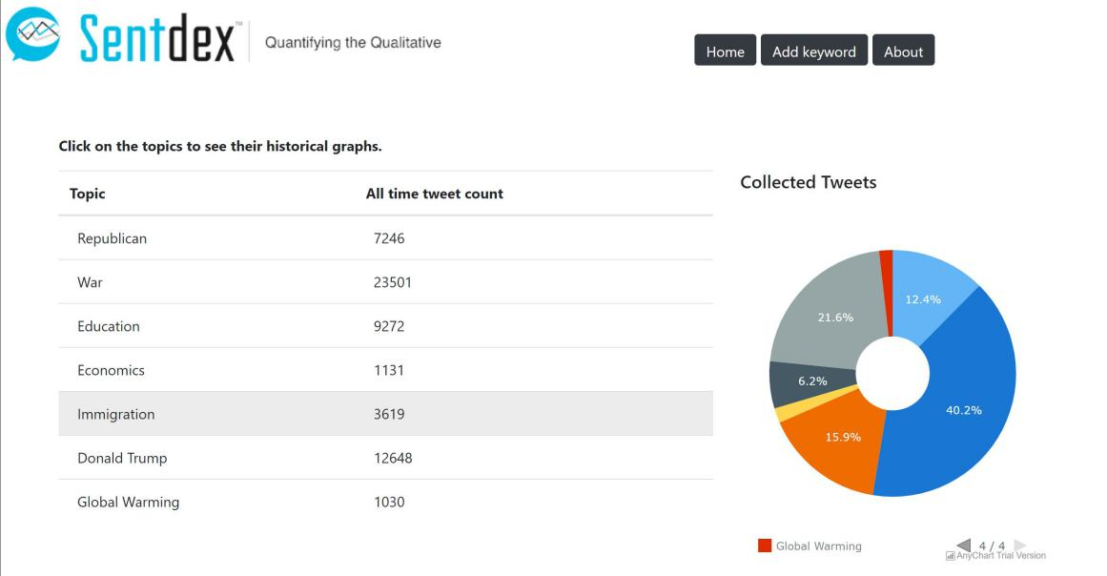

The first interface of the SentViz shows a summary of data in the system. A table and pie chart used to visualize the summary. The table shows all the keywords in the system and the total number of collected tweets. The pie chart gives a quick understanding of the amount of data gathered for a keyword.If user want to access to the result of a keyowrd ,user have to click on the keyword.

2.2 Add Keyword

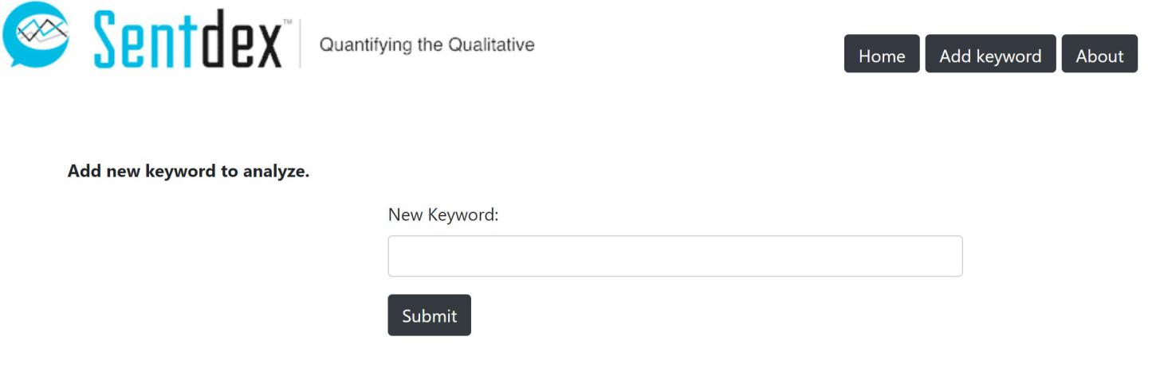

The user can add new keywords to the system. For this user access the add keyword form by click on Add Keyword button. Then enter the new keyword and click on the submit button. The duplicate keywords can't add to the system; it will show an error message.

2.3 Data Visualization Graphs

User can select the time period which use to generate the various graphs. The default time period is seven days, and the user can choose 30 days, six months or 1 year. The emotion timeline shows the number of tweets for each emotion category with respect to the time. The bottom slider can use for enlarge any time period.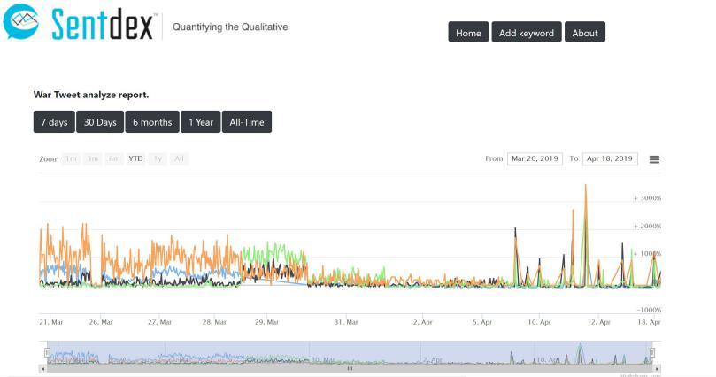

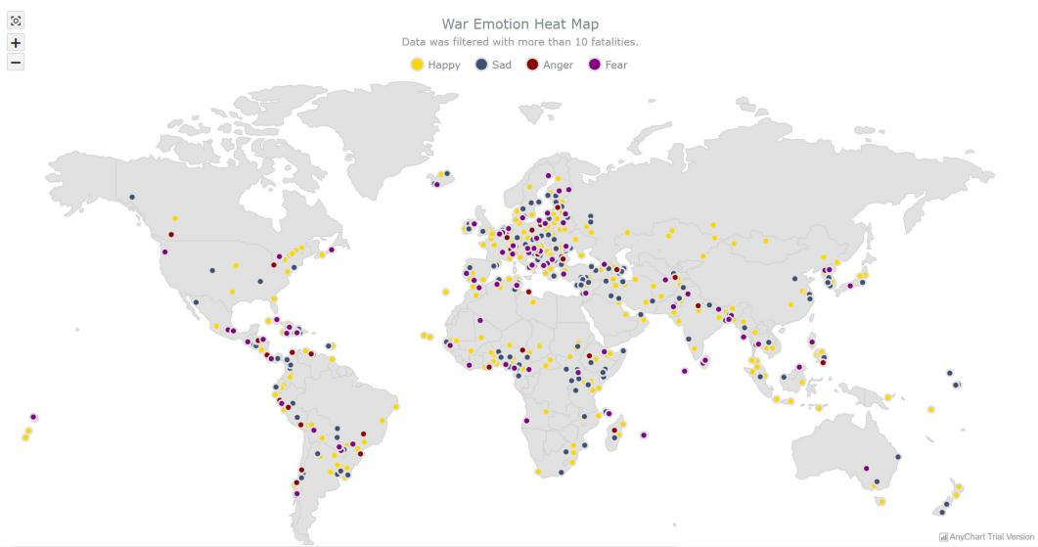

The heatmap shows the analyzed tweets on the world map according to tweets' geo coordinates. This map shows each tweet in a small circle. That circle colors with predefined color to represent the emotion of the tweet. If the user moves the mouse on one of emotion in the top emotion pannel then all the circle which belongs that emotion will be highlighted.The content of the tweet can be viewd by move mouse pointer on the any circle on world map.

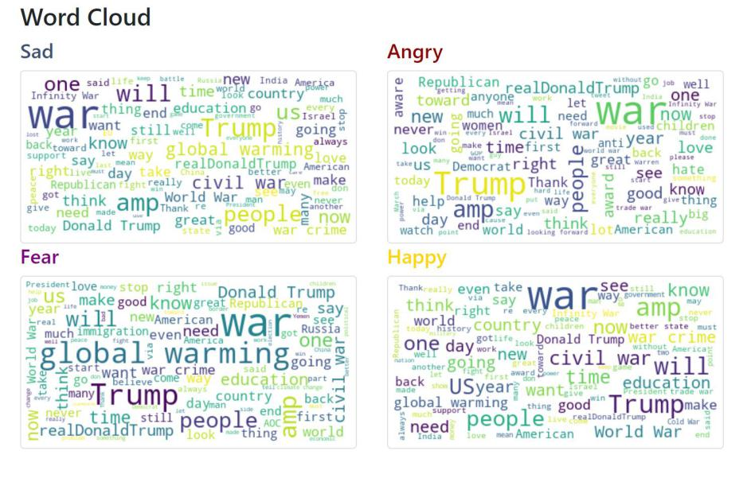

The word cloud generates four images of emotions.Common words from the emotional regions angry, fear, sad, and happy are shown. Words that are more frequent are larger. Hover the mouse over a word to see how often it occurred.

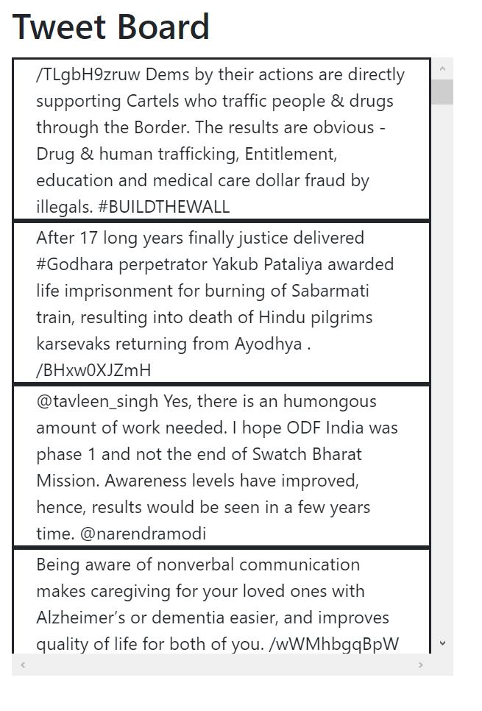

Tweet board shows the collection of 1000 tweets which contains the selected keyword. These tweets collect according to the user selected time period(7days,30 days, 6 months, 1year).User can scroll to view all the tweets.